Cash, Card, or Body Chip? -- 2/20/18
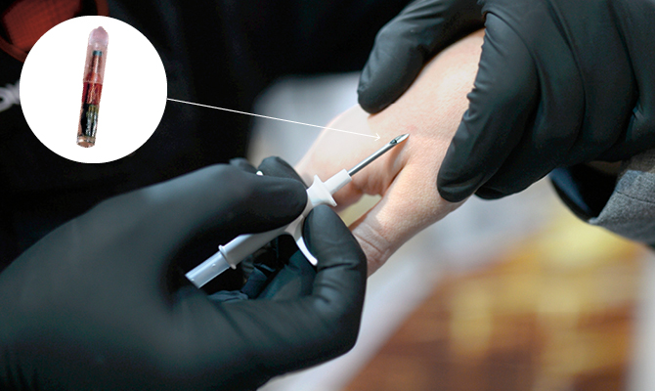
RFID chip, about the size of a grain of rice, being inserted into a hand
Is it the ultimate in convenience, or a terrifying glimpse into the future? Three Square Market (32M), a Wisconsin company, has become the first business in the U.S. to implant microchips into its employees’ bodies. The rice-sized chips, called RFIDs (Radio Frequency Identification), are inserted under the skin of the hand. Employees who get the optional implants can enter the building, buy from the company’s cafeteria, and use machinery with a wave of the hand, eliminating the need for ID cards or money. 32M’s CEO thinks people will eventually use RFID chips to pay for everything from groceries to bus fares. But not everyone’s convinced. Privacy advocates worry the chips could be used to track our movements and could harm our health. Says Matthew Feeney, a privacy expert at the Cato Institute in Washington, D.C., a think tank that pushes for individual rights: “This is people sacrificing their privacy on the altar of convenience.”

The Plight of the Rohingya
A minority group of Muslims has been violently driven out of Myanmar in what experts are calling a case of ethnic cleansing. As her village burned behind her, a young woman named Rajuma was approached by a pack of soldiers. They tore her screaming baby out of her arms, hurled the infant boy into a fire, and dragged Rajuma off.
Survivors of the attack, which happened in the nation of Myanmar, say they saw government soldiers stabbing babies, burning entire families in their homes, and rounding up dozens of unarmed men and shooting them, execution-style. “People were holding the soldiers’ feet, begging for their lives,” Rajuma says. “But they didn’t stop; they just kicked them off and killed them. They chopped people, they shot people, they raped us, they left us senseless.”
Rajuma is a Rohingya Muslim. The Rohingya are a minority group from Myanmar (also known as Burma) that has long been persecuted by the majority population, which is Buddhist. The Rohingya have lived there for centuries, long before the country gained independence from the British in 1948.
In the past few months, more than 620,000 Rohingya have fled their homes in Rakhine State—more than 60 percent of the 1 million who lived there. (Myanmar’s population is 53 million.) The military and, in some cases, Buddhist mobs have been burning villages and killing civilians. Human rights groups say the government troops have one goal: to erase entire Rohingya communities. The United Nations is calling it a “textbook example” of ethnic cleansing. “There are lots of ethnic conflicts all over the world, but it’s rare that a government essentially accuses an entire population of not being citizens and targets them for removal,” says John Sifton of Human Rights Watch.
“This is the ‘never again’ scenario,” he adds, referring to the international pledge that came in the wake of the Holocaust to never let a genocide happen again. “Here we are 75 years later, and there’s another stateless people who are being denied their citizenship and attacked.”
Myanmar’s army claims that it has been acting in response to attacks carried out in late August by Rohingya militants and that it is targeting only insurgents. But according to many eyewitness accounts and human rights groups, the attacks have been widespread and directed at unarmed Rohingya villagers.
Most of the refugees—including Rajuma—have fled to neighboring Bangladesh, a majority-Muslim country. Some have walked for weeks over mountains and through rivers, eating leaves and drinking rainwater to survive. Others have arrived on boats or rafts. The bodies washing up on Bangladesh’s coast hint at how many others have drowned trying to escape.
Vast refugee camps have sprung up in Bangladesh, which is itself a poor country. Despite that poverty, Bangladeshi Prime Minister Sheikh Hasina has welcomed the refugees. Her response stands in stark contrast to that of Myanmar’s leader, Aung San Suu Kyi, who has been sharply criticized for failing to speak out against the military. Suu Kyi, a longtime democracy advocate who was once held under house arrest by the military, won the Nobel Peace Prize in 1991, and many in the international community expected her to come swiftly to the defense of the Rohingya.
The hatred in Myanmar between the Rohingya and the majority Buddhist population goes back to World War II (1939-45). The Rohingya fought with the Allies, while the Buddhists sided with the occupying Japanese. After the Allies won, the Rohingya hoped to be rewarded with independence. But that didn’t happen.
Instead, leaders of the newly independent Burma (Myanmar’s name before 1989) began blaming the Rohingya for the country’s problems, claiming they were illegal migrants from Bangladesh and stripping them of their rights. They have been denied citizenship since 1982, cannot move around the country freely, and have no access to government services like education and health care.
“Year after year, they were demonized,” says Azeem Ibrahim, a Scottish academic who wrote a book on the Rohingya.
The longtime persecution eventually fueled a Rohingya militant movement. Those militants staged attacks on Myanmar military outposts in late August, sparking the current crisis. Now, human rights groups say it’s critical that the international community speak out and demand justice for the Rohingya. “As a society,” says Rich Weir of Human Rights Watch, “we don’t want to live in a world where governments are allowed to target a group like this and do whatever they want.”

