China's National People's Congress will open the way to a dictatorship for President Xi Jinping – 3/5/18
Today in a carefully orchestrated show of unity and strength at the Great Hall of the People in Tiananmen Square in Beijing, China's 13th National People's Congress (NPC) will convene.
Three thousand delegates will arrive from all over China and in theory spend the next two weeks thrashing out policy and direction for the nation in 2018.
The NPC is meant to be the body that ensures the Government and the Communist party adheres to rule of law and the will of the people through elected delegates, much like a parliament in a Western democracy.
The reality is vastly different.
Delegates are handpicked by the Party to enforce decisions taken months ago.
At this congress delegates will rubber stamp critical changes to the constitution that will give the Party more control than ever and give one man, President Xi Jinping the potential to rule for life.
Veteran China watcher Jerome Cohen, from New York University, says it will make Mr Xi "an arbitrary dictator, a complete dictator and the world should be alarmed and outraged".
It's a radical departure from the collective leadership and consensus set up by Deng Xiaoping in the early 1980's that guarded against the dangers of one-man rule and has since delivered stability to China.
Mr Cohen said it was designed to stop the excesses of Chairman Mao's era, which saw "the great leap forward" and "the cultural revolution" that resulted in chaos, destruction and mass death.

Meet China's leaders
Mr Cohen says Mr Xi has dismantled the structures very quickly and this NPC will be the final stage in endorsing China's new totalitarianism.
"Xi has become the central power holder and organiser and he doesn't permit any question to his rule. People say he has taken on the Putin model of dictatorship but he's more like Stalin."
This NPC will give Mr Xi a powerful new tool to ensure dissent can be quickly and effectively quashed.

'A fig leaf of legitimacy'
A new super body called the National Supervision Commission will give the President unrestricted powers, outside any law, to detain Chinese citizens.
The government says it's a necessity to continue its anti-corruption drive but Mr Cohen says it will end up as a nightmare institution.
"This will permit the administration of terror against everyone, they lock you up with no crime, just opposing the state, for six months with no access to family friends or a lawyer. They break people, can torture them, many good people have already been broken like human rights lawyers.
"This new body will be made law by the NPC. It's a fig leaf of legitimacy to provide cover for arbitrary dictatorship."

'The greatest setback for China's political civilisation'
In the last week there have been murmurs of dissent on Chinese social media but it takes a brave soul in China these days to openly defy the President.
Li Datong is the former editor of state-run newspaper The China Youth Daily and is calling on the NPC delegates to vote down the proposal to extend the President's two terms, 10 year rule.
"Lifting the term limits would sow the seeds of chaos and destruction for China. It prevents autocracy or putting individuals above the party and the state," Li Datong says in an open letter to delegates.
Li Datong told the ABC the move was a "backdoor into the emperor system".
"It's the greatest setback for China's political civilisation and will be the backdoor into the emperor system, Mao's emperor system," he said.
"It's not acceptable. No system can control a lifelong tenure. He can act on his own will and worsen the situation for China. There's nothing left and everyone will be scared not knowing what is happening next."
Li Datong laughs nervously when asked about his fear of reprisal or imprisonment but stresses he has to speak out to warn the world because he has no faith in NPC and its members.
"NPC delegates are not the real representatives for the people, they are all puppets. They want to pretend to the international community that China is a republic but it's a republic only in name. it's a complete lie, a fake," he says.
"It is a one-party autocratic country, it is a fascist country, without the freedom of speech and no freedom of association. There is no law. The constitution is a mere scrap of paper. The president is the law."

Fears internal checks and balances gone
This NPC will mark a critical turning point.
Carl Minzner, a professor of law at Fordham University in New York and author of a new book on Mr Xi's increasing authoritarianism, says the move to dictatorship will be formalised in the next couple of weeks and is dangerous for both China and world.
"In China we'll start to see the yes men proliferate and they only reflect back what President wants to hear rather than what is happening. There is the risk policy becomes increasingly erratic as it's subject to the whims of one man. Any internal checks and balances are gone," Mr Minzner said.
China is promoting itself on the world stage as a modern, responsible state, capable of taking the leadership on global trade and climate change but many China experts say those ambitions cannot sit with an inward looking, brutal, autocratic regime.

You can now buy a handgun that looks like a smartphone and police are worried
The gun's handle folds away to disguise the weapon as a smartphone. European police have been warned to remain vigilant as a gun disguised as a mobile phone goes on sale in the US. The Ideal Conceal pistol, a .380 calibre handgun that can be folded up to look like a generic smartphone, will go on sale in the coming months and is expected to be imported illegally into Europe.
Created by Minnesota-based manufacturer Ideal Conceal, the double-barrelled pistol can carry two bullets and comes complete with laser sights. The pistol grip can be folded upwards to disguise the weapon as an unassuming mobile phone, leading it to be dubbed the "iPhone gun".
According to T he Times, Ideal Conceal has already received 12,000 pre-orders for the handgun, which costs $395 (£325, €375). Belgian police, who are already on high alert following a spate of terrorist attacks in Europe in recent months, were issued a warning over the weekend that the gun is expected to turn up on the continent via illegal imports.
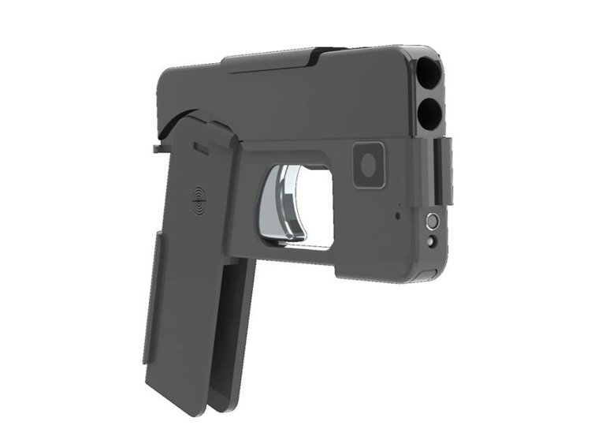Police believe the double-barrelled pistol will make its way to European shores via illegal imports. "To the eye, nothing can distinguish it from a mobile telephone," the police alert read, according to local newspaper Dernière Heure. "Most people possess a smartphone, meaning that it can pass completely overlooked."
According to its manufacturer, the Ideal Conceal pistol has been designed to "hide in plain sight" and easily fits into a purse or back pocket, making it "virtually undetectable". The gun fires high-velocity ammunition, meaning it can be discharged with speed and is hammerless so that the pistol does not have to be "cocked" before being fired. "In today's day and age, carrying a concealed pistol has become a necessity," Ideal Conceal's website reads.
"The idea for Ideal Conceal follows the present-day demand for handguns that people can carry on a day to day basis, in a manner that makes carrying a gun easy to do. From soccer moms to professionals of every type, this gun allows you the option of not being a victim."
The Ideal Conceal pistol was originally supposed to launch in 2016, however, an update posted to the company's Facebook page by founder Kirk Kjellberg on 5 January revealed that it had run into production delays. In July last year, a passenger travelling through Stansted Airport in Essex was stopped by police for carrying an iPhone case designed to look like a gun.

