Donald Trump tweets he's considering pardon of boxer Jack Johnson – 4/23/18
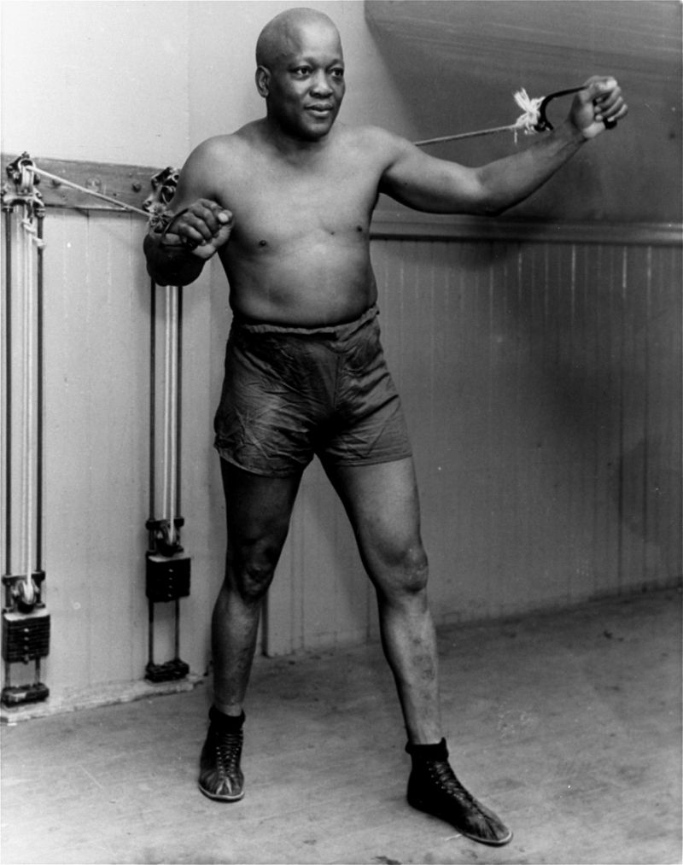
FILE – In this 1932 photo, boxer Jack Johnson poses for a photo in New York City at the age of 54. (AP Photo/File)
President Donald Trump tweeted Saturday that he was considering pardoning the former heavyweight champion after receiving a call from actor Sylvester Stallone.
Sylvester Stallone called me with the story of heavyweight boxing champion Jack Johnson. His trials and tribulations were great, his life complex and controversial. Others have looked at this over the years, most thought it would be done, but yes, I am considering a Full Pardon!
A Trump pardon of Johnson would come after Sen. John McCain (R-AZ) and Sen. Harry Reid (D-NV) pushed then-President Barack Obama to pardon Johnson in 2016 on the 70th anniversary of his death.
Johnson was the first African-American heavyweight champion and was imprisoned on charges for a crime that many believe were racially motivated. He was convicted in 1913 via a purported violation of the Mann Act after he crossed state lines with his white girlfriend. The Mann Act was designed to help combat sex trafficking.
Johnson didn’t serve his prison sentence until 1920 because he left the country following his conviction. He was released in 1921 and continued to box professionally after his release from prison and died at the age of 68 in 1946.
His fight with James Jeffries in 1910 is widely regarded as the “Fight of the Century.” Johnson defeated Jeffries to keep his title as the undisputed champion of the world. Johnson first became the heavyweight champion in 1908 when he beat Tommy Burns in a fight in Sydney, Australia.

