17 States Sue Trump Administration Over Census Citizenship Question – 4/5/18
New York Attorney General Eric Schneiderman (D) filed a federal lawsuit on Tuesday aimed at blocking the Trump administration from adding a question about citizenship to the 2020 census, saying such a question violates the U.S. Constitution’s mandate to count all persons.
In a statement, Schneiderman’s office said the suit was filed on behalf of 17 states plus the District of Columbia, six cities and the U.S. Conference of Mayors. It comes a little over a week after the Commerce Department, which oversees the Census Bureau, announced it would add the question. Schneiderman said the decision to add a citizenship question “blatantly” undermined the Constitution’s mandate to count all people.
“The prospect of someone saying, ‘I am from the Trump administration’ knocking on your door to ask a question about citizenship would understandably provoke real fear,” Schneiderman said during a Tuesday press conference, flanked by members of New York’s congressional delegation.
The numbers from the census are used to determine how many seats each state gets in Congress, as well as how hundreds of billions of dollars in federal funds are allocated. Democratic members of New York’s congressional delegation said Tuesday that the decision to add a citizenship question was an attack on states, like New York, with high immigrant populations in an attempt to cut their congressional representation and share of federal funding.
“It is being added to harm states and cities like New York both politically and financially,” said Rep. Carolyn Maloney (D-N.Y.). “We are being unfairly targeted because we have large, diverse immigrant populations which we welcome and support.”
Civil rights groups voiced loud opposition to adding the question, noting that the bureau has not tested the question and that immigrant groups will be afraid to respond out of fear about their immigration status. In September, census researchers reported they were already seeing an unprecedented amount of concern about the confidentiality of census responses amid the Trump administration’s harsh immigration rhetoric and policies.
The census already asks Americans about their citizenship as part of the American Community Survey, a smaller annual survey that goes out to about 3 million people. The Department of Justice asked the Commerce Department to add a citizenship question to the 2020 census, saying it needed better information to better enforce Section 2 the Voting Rights Act, the landmark 1965 law designed to protect the voting power of minorities. Section 2 prohibits discriminatory voting practices.
The census has not asked about citizenship on the decennial form since 1950, and former top Justice Department officials say that the ACS provides adequate data to enforce the law.
On Tuesday, Schneiderman questioned whether U.S. Attorney General Jeff Sessions was really interested in better enforcing the Voting Rights Act.
“Jeff Sessions has not brought one case under Section 2 of the Voting Rights Act since he’s been Attorney General,” he said.
A Commerce Department spokesman expressed confidence that the decision to add the citizenship question would withstand legal scrutiny.
“We are not going to comment on the specifics of pending litigation, but these cases are without merit. We look forward to prevailing in court and continuing to work with the Census Bureau to conduct a complete and accurate 2020 census,” the spokesman said.

Designer Of Waterslide That Decapitated 10-Year-Old Boy Seized On Murder Charge
The lead designer of a waterslide that killed a 10-year-old boy in Kansas City, Kansas, in 2016 has been taken into custody, according to the U.S. Marshals Service.
Marshals detained John Schooley, 72, at Dallas Fort Worth International Airport on Monday after he arrived on a flight from China, the Marshals Service said in a release. He faces charges of second-degree murder, aggravated battery, and aggravated endangerment of a child.
Schooley played a major role in the creation of Verrückt, a 168-foot-high waterslide that decapitated Caleb Schwab on Aug. 7, 2016, at Schlitterbahn Waterpark, authorities alleged. He was responsible for doing “the math” that went into Verrückt’s design, but had “no engineering credentials relevant to amusement ride design or safety,” according to a lawsuit against the park filed by the state of Kansas last month.
At least 10 other Schlitterbahn customers had been hurt riding Verrückt before Caleb’s death, according to the lawsuit, including broken toes and concussions.
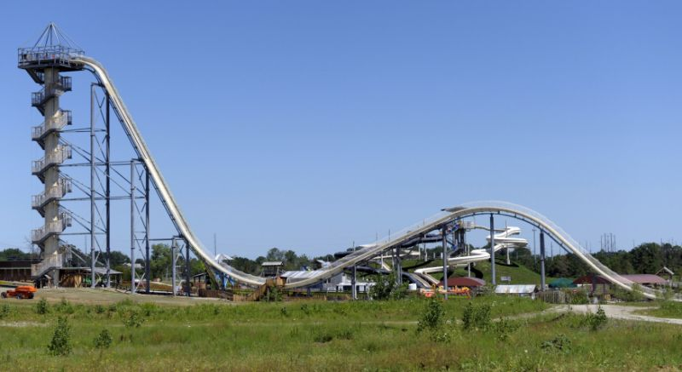
A Kansas grand jury last month indicted Schooley along with the water park, its construction company, park co-owner Jeffrey Henry and former director of operations Tyler Miles on criminal charges in Caleb’s death. Miles pleaded not guilty last month to involuntary manslaughter. Henry is scheduled to enter a plea to a second-degree murder charge on Thursday, according to The San Antonio Express-News.
Schlitterbahn has denied wrongdoing, and defended Miles, Henry and Schooley in a statement last week.
“Jeff Henry has designed waterpark rides the world over,” the statement said. “Nearly every waterpark that exists today has an attraction or feature based on his designs or ideas. The incident that happened that day was a terrible and tragic accident. We mourn the loss of this child and are devastated for his family. We know that Tyler, Jeff, and John are innocent and that we run a safe operation – our 40 years of entertaining millions of people speaks to that.”

